NAME: ______________________________

**ECE 111**

**EXAM 2**

**Fall 2012**

FOR GRADERS’ USE ONLY.

|  |  |  |
| --- | --- | --- |
| PROBLEM # | GRADE | POINTS |
| 1 |  | 8 |
| 2 |  | 12 |
| 3 |  | 36 |
| 4 |  | 32 |
| TOTAL |  | 88 |

1. (2 points each, 8 points total) Match the letter of the Configuration with the appropriate circuit diagram:

A) Inverting Configuration

B) True Differential Configuration

C) Non-inverting Configuration

D) Buffer Configuration

V2

V1

**+**

**-**

**+**

**-**

**+**

**-**

**Vout**

**+**

**-**

Rf

Rf

Ri

Ri

Vin

**+**

**-**

**+**

**-**

**+**

**-**

**Vout**

Configuration: ___**__**___ Configuration: ___**__**___

**+**

**-**

**+**

**-**

Vin

**+**

**-**

**Vout**

Vin

**+**

**-**

**+**

**-**

**+**

**-**

**Vout**

Configuration: ___**__**___ Configuration: ___**__**___

2.) (12 points total)

Given this circuit containing an Ideal Op-Amp, capable of Rail-to-Rail operation (that is, the output is able to go all the way to the supply voltage):

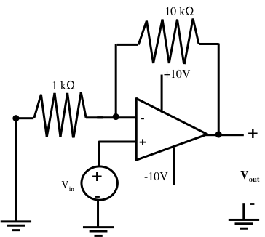

A. (2 points) Is this: Non-Inverting, Inverting, Comparator, Differential, or Buffer Configuration (CIRCLE ONE.)

B. (6 points) Given part A, what is the output Vout in terms of the input Vin?

C. (2 points) If Vin is 0.3V, what will the output be?

D. (2 points) If Vin is 2V, what will the output be?

3. (36 points total)

Given the circuit below, in which the switch has been closed for a long time and opens at t=0, answer the following questions:

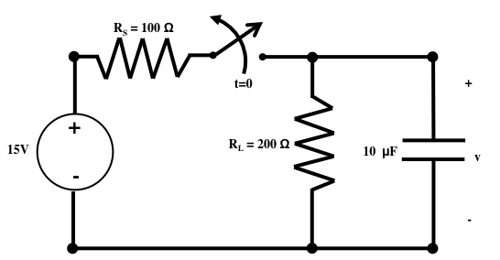

A. (4 points) If I asked you for the TOTAL response of anything in this circuit (current through or voltage across ANY passive element) and I called it Y(t), what general form would it take?

Y(t) = ___________________________________________________

B. (6 points) Which quantity, voltage across or current through which element in this circuit, MUST be continuous across the switch closing, and what is its initial value? (I.e., what is the State Variable for this circuit?)

NOW, I am going to ask you to find the voltage across the capacitor, v (t).

C. (2 points) What is the value of v just before the switch opens(i.e., v(0-))?

D. (4 points) What is v just after the switch opens (i.e., v(0+))?

E. (2 points) What is the decay constant, τ? (NOTE: This is for time t≥0.)

F. (4 points) What is v a long time after the switch opens (i.e., v())?

G. (8 points) Evaluate the constant(s) and give the formula for v(t) for all times t:

v(t) = ______________________________________________________________

H. (2 points) How long would I have to wait to make sure all transients from the switch have died away?

I. (4 points) Sketch v(t):

**V**

**t**

4. (32 points total)

Given the circuit below, in which the switch has been open for a long time and closes at t=0, answer the following questions:

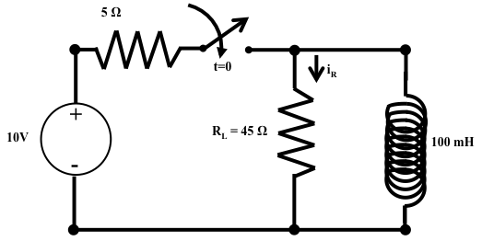

A. (6 points) Which quantity, voltage across or current through which element in this circuit, MUST be continuous across the switch opening, and what is its value at t=0-?

NOW, I am going to ask you to find the current through the resistor, iR(t).

B. (2 points) What is the current through the resistor just before the switch closes, iR at t=0-?

C. (4 points) What is the current through the resistor just after the switch closes, iR(0+)?

D. (2 points) What is the decay constant, τ? (NOTE: This is for time t≥0.)

E. (4 points) What is iR a long time after the switch closes, iR()?

F. (8 points) Evaluate the constant(s) and give the formula for iR(t):

iR(t) = ______________________________________________________________

G. (2 points) How long would I have to wait to make sure all transients from the switch have died away?

H. (4 points) Sketch iR(t):

